Individual assignment: Business Reporting Tools

*For Professor Mathijs Meire*

By Edward Vrijghem (Master Big Data Analytics)

Link

<https://public.tableau.com/profile/edward3759#!/vizhome/IndividualAssignment_EdwardVrijghem/Welcome?publish=yes>

Part 1: Analyzing the data

**Customers**

Here I display the top 25 customers (according to total spent) as well as the cities with the most orders. You can click the customer to see the city he or she is located in.

**Sales**

In the sales table I made a general overview of the revenue per quarter/year/month, I also added filters to select specific information.

**Tracks**

Here I gave a general summary of tracks, genres, revenue per track and per genre.

**SalesEmployees**

This sheet is made to track the performance of the different sales employees and the number of customers they treated in a certain period. I also categorized the total sales into low, average and high.

Part 2: Visualizing a mission and strategy

**Mission:** Increasing our market share by increasing current customer worth through personalized advertisements, and ever increasing track base. Increasing profits by improving worker productivity. As well as expanding our operations to previously untapped markets, and fortifying our position there where needed.

**Strategy:**

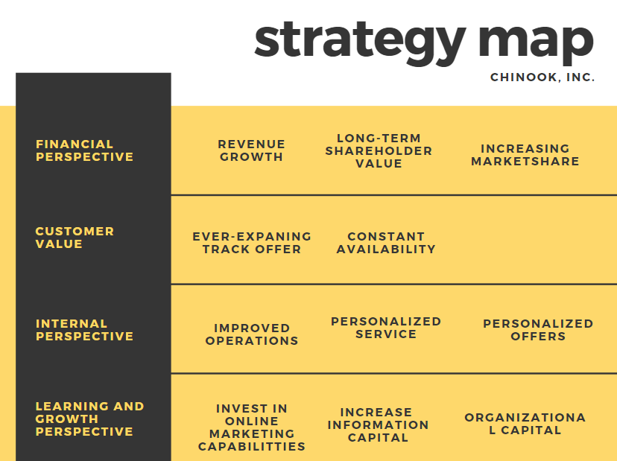

Part 3: Balanced Scorecard

**General**

With my BSC I wanted to be able to see how the company is doing by adding 5 KPI’s which are associated with my strategy and mission.

I added their trend (increasing/decreasing) compared to the previous year together with a graph so the full trend is visualized and the individual trends ar, and the specific values can be observed. This allows the user to quickly analyze the most important KPI’s and to see how the company is performing compared to previous years.